June 2023

Older people experiencing vulnerability and multiple disadvantage in New Zealand
  - A report on the needs of older people (65+) in health, housing, finance, social connection, and access.

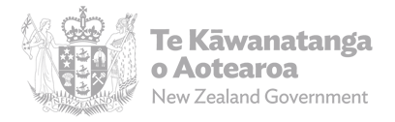

Author
Dr Sarah Ann Pinto, Dr Penny Mok, and Verity Warn

Acknowledgements
Kirsty Anderson, Beth Charlton, Megan Davis, Uekaha Douglas, Rebecca Hollingsworth, Josh Logan, Louise Pirini, Craig Wright (SWA), Alice Ansley, Jeffrey Azzato, Julia Bergman, Harry Fenton, Erin Gough, Lynley Hutton, Emma King, Miriam Mathews, Maryam Ghorbanpour Rasekh, Sophie Ross (MSD), Kristy Udy and Jacob White (MoH), and the Office for Seniors.
Special thanks to the Expert Advisory group members: Prof Fiona Alpass, Prof Vanessa Burholt, Dr M. Claire Dale, Dr Ofa Dewes, Dr Bev James, Linda Murphy, Rangimahora Reddy, Bonnie Robinson MNZM, Gilli Sinclair, and Charles Waldegrave.

Creative Commons Licence
This work is licensed under the Creative Commons Attribution 4.0 International licence. In essence, you are free to copy, distribute and adapt the work, as long as you attribute the work to the Crown and abide by the other licence terms. Use the wording ‘Social Wellbeing Agency’ in your attribution, not the Social Wellbeing Agency logo.
To view a copy of this licence, visit creativecommons.org/licenses/by/4.0.

Liability
While all care and diligence has been used in processing, analysing and extracting data and information in this publication, the Social Wellbeing Agency gives no warranty it is error free and will not be liable for any loss or damage suffered by the use directly, or indirectly, of the information in this publication.

IDI Disclaimer
These results are not official statistics. They have been created for research purposes from the Integrated Data Infrastructure (IDI) which is carefully managed by Stats NZ. For more information about the IDI please visit https://www.stats.govt.nz/integrated-data/
Access to the data used in this study was provided by Stats NZ under conditions designed to give effect to the security and confidentiality provisions of the Data and Statistics Act 2022. The results presented in this study are the work of the author, not Stats NZ or individual data suppliers.
The results are based in part on tax data supplied by Inland Revenue to Stats NZ under the Tax Administration Act 1994 for statistical purposes. Any discussion of data limitations or weaknesses is in the context of using the IDI for statistical purposes, and is not related to the data’s ability to support Inland Revenue’s core operational requirements

Citation
Social Wellbeing Agency 2023. Older people experiencing vulnerability and multiple disadvantage: A report on the needs of older people (65+) in health, housing, finance, social connections, and access. Wellington, New Zealand.
ISBN 978-1-99-117854-1 (online)

Published in June 2023 by
Social Wellbeing Agency
Wellington, New Zealand
Contents
Overview 5
Context 7
Objective and method 8
Older people in New Zealand 11
Physical and mental health 13
Housing 18
Finance 24
Social connection 28
Access 30
Multiple disadvantage 32
Conclusion 38
Notes 39
References 39
Further reading 41

Overview
Toi Hau Tāngata The Social Wellbeing Agency (SWA) has worked in partnership with Te Manatū Whakahiato Ora Ministry of Social Development (MSD) and Manatū Hauora Ministry of Health (MoH) to build an evidence base on the needs of older people aged 65 or older across five life domains. This report uses the Integrated Data Infrastructure (IDI) to estimate and characterise the needs of older people in health, housing, finance, social connection, and accessibility. This report supports commitments by MSD and MoH under the Better Later Life Strategy Action Plan 2021 – 2024 - He Mahere Hohenga.

Summary
- This study measures the needs of older people in multiple life domains using the Integrated Data Infrastructure (IDI). It addresses an important knowledge gap on experiences of older New Zealanders across these domains. Through this work, we have established a more nuanced understanding of the experiences of older New Zealanders who are often characterised as a homogenous group that experiences better outcomes than the rest of the population.
- This work provides an overview of need, including the size and the characteristics of older people experiencing vulnerability. It provides insights into where the overlapping vulnerabilities (or multiple disadvantages) across domains are most prevalent; and where the most acute need may lie.
- For each of the five domains we created new indicators that can be applied beyond the scope of this project to understand needs among other population groups.
- Fifty-four percent of older people are healthy, have liveable housing, are financially secure, and have good social connections and access based on our measures. However, at least 33 percent experience vulnerability and 13 percent experience multiple disadvantage i.e., vulnerability across two or more domains. In this group, we found a complex spectrum of need, including groups of older people experiencing multiple mental health conditions paired with compounding housing and financial vulnerability.
- Our findings of varied experiences of vulnerability for older people are consistent with the inequitable experiences and outcomes of Māori and Pacific peoples across the life course. We also know that Māori and Pacific peoples have different life expectancy. The average life expectancy for men of Māori and Pacific ethnicities is 73.4 and 79 years respectively. By contrast, the average life expectancy for men from all other ethnicities is above 80. The data suggests, therefore, that to improve wellbeing for older adults, there is a need to improve how the system supports outcomes for Māori and Pacific peoples earlier in life.
- Older Pacific peoples experience the highest proportions of housing vulnerability compared to all other ethnicities. Asian and MELAA (Middle Eastern, Latin American, and African) older people experience the highest proportions of financial vulnerability. Māori older people experience the highest proportion of health vulnerability and, European older people experience the highest proportion of social connection vulnerability.
- Older Pacific peoples, irrespective of sex, were more likely to experience multiple disadvantage at 27 percent compared to all other subgroups we analysed based on sex and ethnicity.
- The research was based on the most recent 2018 Census data which includes information on home ownership and other socio-economic variables that are not available elsewhere. These sources do not consider the impacts of the COVID-19 pandemic, the Auckland floods, Cyclone Gabrielle, and the rising cost of living. Hence, the picture of need in this report is likely to be understated.

Context
According to the 2018 Census, about 715,200 New Zealanders, or 15 percent of the population are aged over 65. Due to declining fertility rates, the ageing of the baby boomers’ generation and an increase in average life expectancy, the over 65 age group will increasingly account for a larger proportion of our population. Stats NZ projects this group will increase to about 1 million people or 19 percent of the population by 2028.
The population is ageing, and people are living longer. This will likely mean that the number of older people experiencing vulnerability and multiple disadvantage will also increase which could lead to poorer outcomes later in life. In 2019, the Government launched the Better Later Life He Oranga Kaumātua Strategy in 2019 to recognise the need to understand and better service the multifaceted needs of older people.

Better Later Life Strategy
The Better Later Life – He Oranga Kaumātua Strategy 2019-2034 (BLL Strategy) is the Government’s strategy for an ageing population seeks to ensure that all New Zealanders lead valued, connected and fulfilling lives as they age. The BLL Strategy identifies five key areas for action. The Action Plan 2021 – 2024 – He Mahere Hohenga sets out a range of actions to be taken by central government to realise the BLL Strategy’s vision.
MSD and MoH are responsible for two of these actions within the action area “Promoting healthy ageing and access to services” (highlighted in Figure 1) (Office for Seniors, 2021):
- Improve support for socially isolated and other vulnerable people (MSD)
- Address the physical and social determinants of health (MSD +MOH)

Toi Hau Tāngata The Social Wellbeing Agency (SWA) is working in partnership with Te Manatū Whakahiato Ora Ministry of Social Development (MSD) and Manatū Hauora Ministry of Health (MoH) to advance these two actions by better understanding the characteristics of older people with needs that cross multiple domains of life. In defining these domains, this work has utilised the five BLL Strategy action areas.

Figure 1: Key areas of the Better Later Life Strategy

Objective and method

Aim
Our objective was to create a preliminary evidence base using the IDI that measures and characterises older people’s experiences of vulnerability and multiple disadvantage, with the ultimate aim of ensuring that services for this group are fit for purpose.

Approach: a focus on multiple disadvantage
This analysis focussed on estimating and characterising older people’s experiences of vulnerability. We were particularly interested in understanding people’s experiences of vulnerability across multiple domains, as this helps us identify overlapping and more complex needs. We defined an experience of overlapping vulnerabilities or vulnerability in two or more domains as multiple disadvantage.
We use the terms ‘vulnerability’ and ‘multiple disadvantage’ as they help capture the complexity and unique nature of older people’s needs. While these terms are deficit focussed, our aim is to create an evidence base that will help policy makers asses where the greatest and most complex needs lie. This approach helps us consider the types of circumstances a person might be experiencing that point towards the risk of poor life outcomes. We do not consider vulnerability as a definitive state but rather as an experience. Further, understanding risk factors a person might be vulnerable to (and using our data to determine the size of the need), also helps us understand resilience factors. While we identify older people’s experiences of vulnerability, the BLL Strategy identifies features of resilience for older people in each of the domains (Office for Seniors, 2021).
Our approach was further tested with an Expert Advisory Group for this project which MSD brought together for the purpose of advising on the direction and delivery of this project. This group is made up of sector experts who confirmed that a focus on multiple disadvantage would best capture the complex spectrum of older people’s needs.

Data
We used the Integrated Data Infrastructure (IDI) as our data source for this project. The IDI is a large research database that collects individual level data about people and households. It includes administrative data about education, income, benefits, migration, justice, and health and comes from government agencies, Stats NZ surveys, and non-government organisations (NGOs). The data is integrated at an individual level and de-identified so personally identifying information has been removed (name, day of birth, address). We overlayed the domain data with people characteristics including age, sex, ethnicity, and region.
The approach was based on the most recent 2018 Census data which includes information on home ownership and other socio-economic variables that are not available elsewhere. Therefore, the population cohort was selected from a 2018 year. In the IDI we identified the New Zealand resident population aged 65+ at June 2018 and those residing in the country for at least six months between April 2017 and March 2018. This excludes tourists and other short-term residents. The resident population aged 65 and above in this study is 686,600.
The numbers presented in this report are likely to be understated since the data is mainly service use data, which does not tell us about unmet need. Further, since the data is from 2018 it does not account for recent events such as the COVID-19 pandemic, Auckland floods, Cyclone Gabrielle, and the rising cost of living that have had an impact on older people’s needs.

Indicators
We developed a set of indicators within the IDI to measure vulnerability aligned with key domains of the BLL Strategy. The indicators were developed as quantitative metrics to measure hardship associated with the MSD and MoH actions of the BLL Strategy. Table 1 lists the indicators, measurement, and datasets sourced in the IDI.

Table 1 Indicator and measurement
Domains | Indicators | What the indicator measures
Finance | Financial vulnerability | Number of seniors receiving any MSD income-tested benefits: Main benefits (i.e., Emergency Benefit, Supported Living Payment, Jobseeker Support, Widow’s Benefit, Sole Parent Support etc); Accommodation Supplement; Temporary Additional Support; Special Needs Grants.  Sources: Inland Revenue (IR) and Ministry of Social Development (MSD)
Health | Health vulnerability | Number of seniors experiencing two or more physical health and/or mental health conditions as defined below.  Physical health: Number of seniors who have been hospitalised for or received medication for any of these conditions: Chronic Obstructive Pulmonary Disease; Dementia, Alzheimer’s and Parkinson’s; Diabetes; Cancer; Falls; Stroke; and Ischemic Heart Disease.  Mental health: Number of seniors who have been hospitalised for or diagnosed or received medication for any of these conditions: Alcoholism; Bipolar; Dysthymia; Generalized Anxiety Disorder; Schizophrenia; Other Drug Addiction; and Major Depressive Disorder.  Note: All these conditions resulted in the largest health utility loss for older people in the Global Burden of Disease (up to 67% of utility loss).  Source: Ministry of Health (MoH)
Housing | Housing vulnerability | Number of seniors experiencing poor housing quality and/or overcrowding.  Poor housing quality: Number of seniors living in any of the housing conditions: mould size larger than an A4 paper; always/sometimes damp; missing at least 1 basic amenity such as cooking facilities or electricity; and no heating used.  Overcrowding: Number of seniors living in houses where extra bedroom(s) are needed.  Source: Census 2018
Social connection | Social connection vulnerability | Number of seniors living alone and not helping whānau and/or not volunteering in the community.  Source: Census 2018
Access | Access vulnerability | Number of seniors who do not have a driver’s licence and live in a household that does not own a vehicle.  Sources: New Zealand Transport Agency (NZTA) and Census 2018

Older people in New Zealand
In the data, 87 percent (595,400) of older people identify as European, 7 percent (47,300) as Māori, 6 percent (42,000) as Asian, 3 percent (19,900) as Pacific peoples, 2 percent (13,600) as Other, and about 1 percent (4,200) identify as MELAA (Middle Eastern Latin American, and African). European older people form the largest group therefore, if we focus on numbers, this cohort would have the most needs. However, our analysis of population subgroups showed that vulnerability is not experienced evenly throughout the older population.
Our ageing population will become more ethnically diverse (Healthy Ageing Strategy, 2016). By 2028, the older Māori population will increase to 9 percent of the older people population and by 2034 to 10 percent (Stats NZ, 2018).
Our population also has different life expectancies. In New Zealand, the current average lifespan for men and women is 80 years and 83.5 years respectively (Stats NZ, 2021). However, there are significant lifespan inequities between subgroups. The average life expectancy for men of Māori and Pacific ethnicities is 73.4 and 79 years respectively. By contrast, the average life expectancy for men from all other ethnicities is above 80. Further, the earlier onset of age-related disease among Māori means that the 65 and above age threshold of some supports does not always support those who may need it earlier (Northland District Health Board, 2008; Stats NZ, 2018).
European older people become an increasingly larger proportion of each age group, as people in other ethnicities die younger (Figure 2). By contrast, older people across other ethnicities become a smaller proportion of their age cohort as they age (Figure 2). The data suggests, therefore, that to improve wellbeing for older adults, there is a need to improve how the system supports outcomes for Māori and Pacific peoples earlier in life.

Figure 2: Population distribution of older people by age and ethnicity
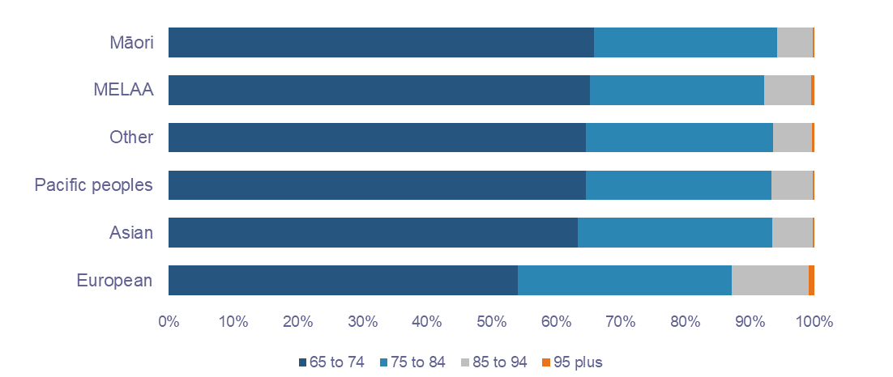

54 percent (367,000) of older people are doing well
Based on our measures, 54 percent of older people do not experience any vulnerability. But 33 percent (229,100) of older people experience vulnerability in a single domain and 13 percent (90,400) of older people experience vulnerability in two or more domains (multiple disadvantage). The most significant shift in older people’s vulnerability experiences was observed for those aged 85-94. In this age group, a larger proportion experience vulnerability than are doing well.
As our datasets are from 2018, the number of older people identified as experiencing vulnerability are likely underestimated. Factors such as the COVID-19 pandemic, the Auckland floods, Cyclone Gabrielle, and the rising cost of living may have increased the number of people experiencing vulnerability. Additionally, other risk factors pose serious challenges to the wellbeing of older people in the future and may also inflate this number. For example, the current trend of decreasing home ownership rates (particularly for those who are currently pre-retirement), or an increase in life expectancy without a corresponding increase in health expectancy (i.e., people are living longer but spending more time in poor health) (Ministry of Health, 2018).
We know that Government systems and services are starting to feel the pressures of an ageing population. While older people are living longer, that does not mean they are experiencing better outcomes, as longer lives can lead to increased complexity of required care. These system challenges will require Government to consider how to provide social supports and services that are fit-for-purpose now and in the future (Healthy Ageing Strategy, 2016).

Physical and mental health
Remaining in good health, ageing well and being able and supported to live well with long-term conditions, however complex, is critical to enabling older people to continue participating and feeling valued (two important factors for health and wellbeing) (Health Ageing Strategy, 2016).
To understand the health needs of older people, we measured health vulnerability using the indicators for physical and mental health. We defined health vulnerability as an experience of two or more physical or mental health conditions (see Table 1 for list of physical and mental health conditions). For our analysis, we refer to three combination types of health vulnerability:
- Multiple physical conditions
- Multiple mental conditions
- Combination of physical and mental conditions

Some older people may have a single but severe health condition (i.e., Cancer, COPD, Schizophrenia, Dementia, Alzheimer’s, and Parkinson’s). We did some preliminary analysis on older people with such a condition, but they are not included in this report.

Older people are most likely to experience health vulnerability
Twenty-four percent (167,900) of older people experience health vulnerability. This group represented the largest cohort who experience vulnerability compared to vulnerability in any other domain. Most health vulnerability is due to multiple physical conditions (Figure 3).

Figure 3: Older people experiencing health vulnerability
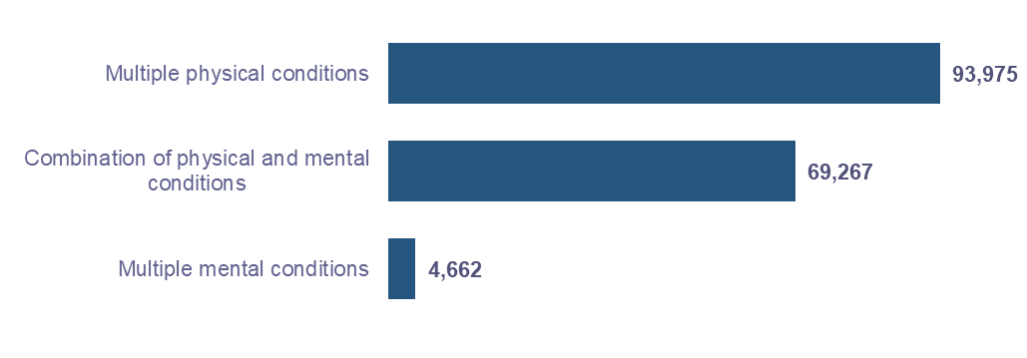

Older men and women have different experiences of health vulnerability
Men are more likely than women to experience health vulnerability due to multiple physical conditions. A similar number of men and women experience multiple physical and multiple mental health conditions. However, in all other health condition combinations women account for the majority (Figure 4).

Figure 4: Experiences of health vulnerability by sex
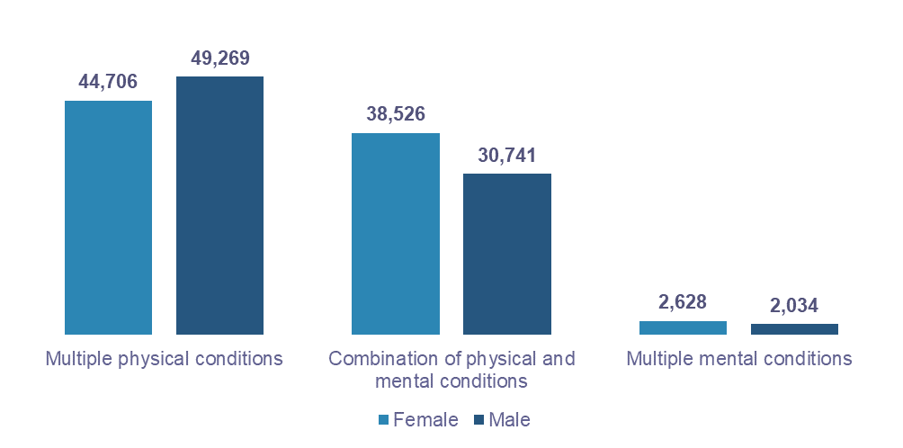

Māori older people experience the highest proportion of health vulnerability
We found that older Māori, Pacific peoples, and MELAA people were more likely to experience poor health. For example, 30 percent (14,300) of Māori, 29 percent (5,800) of Pacific peoples, and 28 percent (1,200) of MELAA older people experience health vulnerability (Figure 5). Whereas European and Asian older people have lower rates of health vulnerability at 24 percent (145,400) and 19 percent (8,100) respectively. Different subgroups have varied ageing experiences and it is crucial to understand these differences, as since the onset of health conditions has a significant impact on people’s quality of life.
As observed in other studies, significant health outcomes and access inequities exist between Māori and non-Māori (Edwards et al., 2018; Ellison-Loschmann L, Pearce N., 2006). These health outcomes have been impacted by social determinants of health, including colonisation. In Hauora: Report on Stage One of the Health Services and Outcomes Kaupapa Inquiry, the Waitangi Tribunal noted that “the colonisation of New Zealand and its ongoing impacts are as much a determinant of Māori health outcomes as any other, and continue to manifest as institutional racism” (Waitangi Tribunal, 2023). Despite a higher proportion of Māori having health needs, many face systemic barriers in accessing health care, due to their experiences of a health system they describe as “hostile and alienating” (Graham, & Masters-Awatere, 2020). To improve health outcomes for Māori, the systemic barriers must be addressed so that services are accessible and culturally appropriate.

Figure 5: Older people with health vulnerability by ethnicity
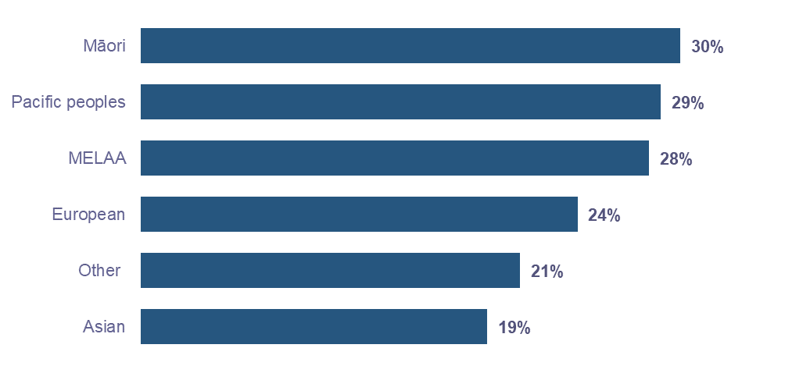

There is an 8 percentage points difference in health vulnerability between older people in urban areas compared to rural areas
Twenty-six percent of older people in urban areas experience health vulnerability compared to 18 percent of older people in rural areas (Figure 6). This difference does not mean that older people in rural areas are in better health, rather it could indicate a gap in services for older people in rural areas (Jaye, C. et.al., 2022).

Figure 6: Older people’s experiences of health vulnerability in urban and rural areas

Older people in Gisborne experience the highest proportion of health vulnerability
Gisborne has the highest proportion of older people who experience health vulnerability at 29 percent. Several other regions had at least 25 percent of older people who experience health vulnerability, including West Coast, Auckland, Canterbury, Otago, Taranaki, and Southland (Figure 7).
In all regions except the West Coast, older people were more likely to experience health vulnerability due to multiple physical conditions. In the West Coast region, 54 percent (800) of older people who experience health vulnerability have either a single or multiple mental health conditions. The West Coast region also has the highest proportion of older people with at least one mental health condition (Figure 8).

‘People with the highest needs may be those who have the fewest resources and the least capacity to address those needs (Healthy Ageing Strategy, 2016).’

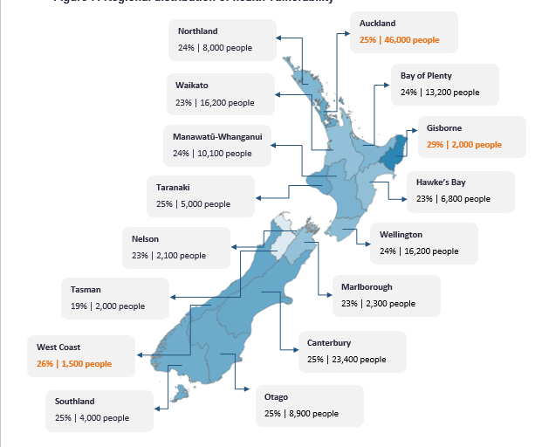
Figure 7: Regional distribution of health vulnerability

The timeframe for the BLL Strategy is until 2034, when the older people population is estimated to be around 1.2 million, with nearly 162,100 people aged 85 and over (Stats NZ, 2018). Those over 65 will account for just over a fifth of our total population. The increasing size of the ageing population is likely to result in an increasing number of people with health issues and disabilities, which could result in increased demand for new services. Therefore, current services should be assessed to understand whether they will be fit for purpose in future years (Office for Seniors, 2021).

Figure 8: Types of health vulnerability by region
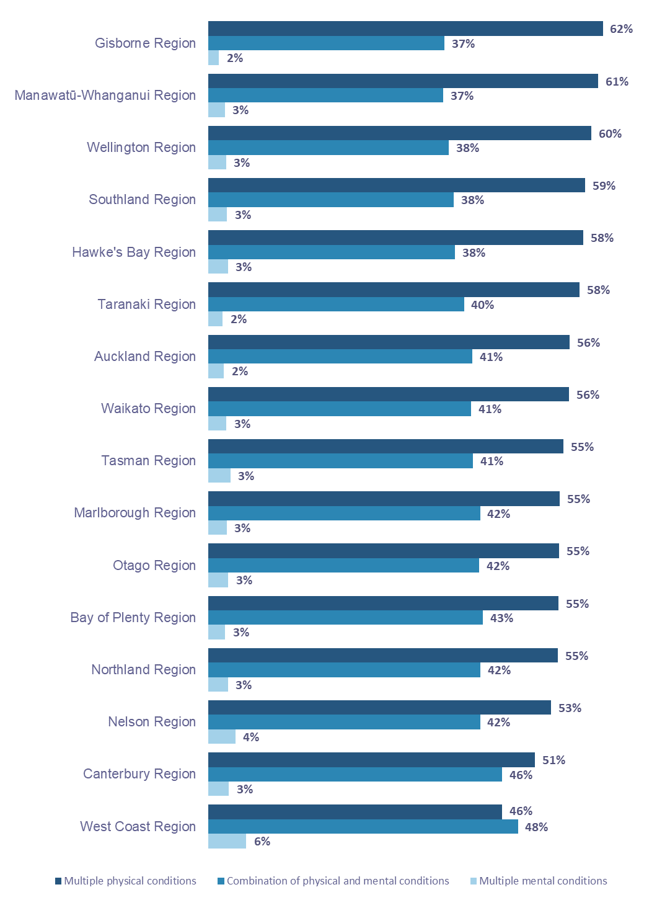

Housing
We defined housing vulnerability as an experience of poor housing quality and/or overcrowding.
- ‘Poor housing quality’ is defined as a house that is damp or mouldy or missing basic amenities or with no heating.
- ‘Overcrowding’ is when the dwellings that people live in are too small to accommodate the number of people in a household, hence extra bedrooms are needed. This measure is based on the Canadian Occupancy National Model (Stats NZ, 2020).
Due to data gaps at the national level, our analysis does not present data on older people who experience homelessness. However, research shows about 3,098 older people are severely housing deprived. Auckland, Bay of Plenty, Waikato, and Wellington have the highest numbers of older people who were severely housing deprived (Amore et al., 2021).
Our housing domain analysis was based on self-reported Census 2018 data, for which the response rate was 77 percent of people aged 65 and over in New Zealand (528,600 out of 686,600 older people). Questions on the quality of housing are based on occupied private dwellings. This captures most of the older people living in private dwellings (such as private homes and retirement villages). Data on housing quality for seniors living in non-private dwellings such as aged residential care and hospitals are not available. Our data predates the introduction of the Winter Energy Payment in July 2018 which may have improved the wellbeing of older people (Hyslop et al., 2022; Webber et al., 2022).
We are aware that a limitation of our definition of overcrowding is that it may not reflect actual need. Our definition is based on the Canadian National Occupancy Standard which reflects a Eurocentric perspective that is not consistent with how many communities in Aotearoa view and value living in multi-generational households.

18 percent (97,300) of older people experience housing vulnerability
These older people live in poor quality or/and overcrowded houses. Looking at the distribution of housing vulnerability types, experiences of poor quality housing (without overcrowding) accounted for the largest share of housing vulnerability (Figure 9).

Figure 9: Older people with housing vulnerability by housing vulnerability type
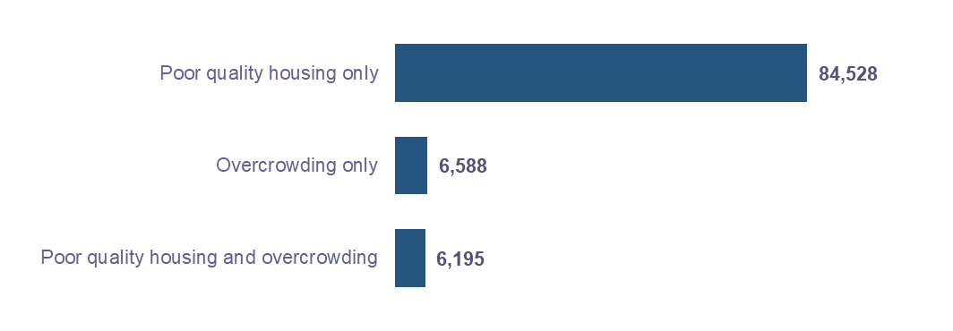
Numerically, most older people who experience housing vulnerability are women (51,400). However, proportionally, men and women have the same rates of housing vulnerability at 18 percent. The distribution of housing vulnerability types was also similar between men and women, with poor quality housing being the most likely type of housing vulnerability for both groups (Figure 10).

Figure 10: Older people with housing vulnerability by housing vulnerability type and sex
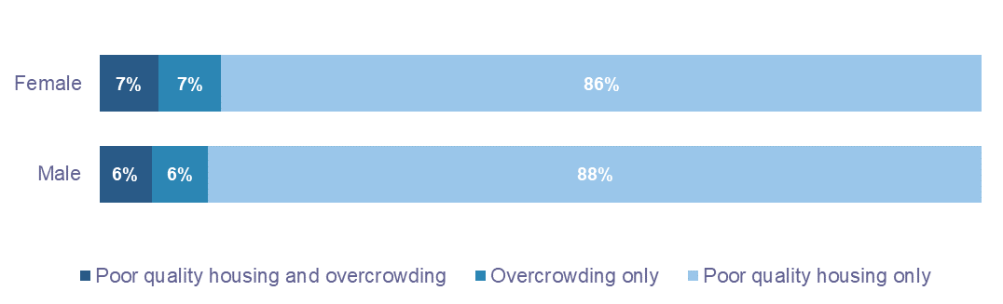

Renters have the highest proportion of housing vulnerability
Of those older people who experience housing vulnerability, 52 percent (50,600) have no mortgage and were not paying rent, 27 percent (26,700) are renting, and 21 percent (20,000) are paying a mortgage.
The data shows that housing tenure impacts housing experience. Older people who rent experience higher rates of housing vulnerability at 40 percent, compared to those with a mortgage at 26 percent and those with no mortgage and no rent at 14 percent (Figure 11).

Figure 11: Older people with housing vulnerability by tenure
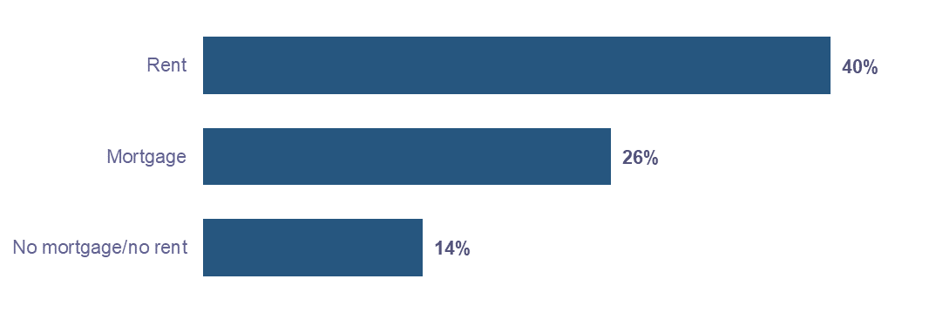

Patterns of housing vulnerability and tenure vary across the country
The regions with the highest proportions of housing vulnerability were Auckland (26 percent or 35,200 older people), Northland (23 percent or 5,900 older people), Gisborne (22 percent or 1,100 older people), and West Coast (21 percent or 900 older people).
Looking at housing vulnerability and tenure together, there is a high proportion of older people experiencing vulnerability among those paying rent or mortgage (as in Figure 12). The regions with the highest proportion of vulnerability are different when focusing on tenure.
Northland has the highest proportion of older people with no mortgage/no rent who experience housing vulnerability (19 percent or 3,600 older people), followed by Auckland (18 percent or 15,500 older people) and the West Coast (17 percent or 500 older people) (Figure 12 A).
Auckland has the highest proportion of those paying a mortgage who experience housing vulnerability (33 percent or 8,500 older people), followed by Northland (31 percent or 1,100 older people) and the West Coast (30 percent or 150 older people) (Figure 12 B).
Auckland has the highest proportion of older renters who experience housing vulnerability (51 percent or 11,200 older people), followed by Northland (44 percent or 1,300 older people), Gisborne (42 percent or 300 older people) and Wellington (39 percent or 2,600 older people) (Figure 12 C).

Figure 12: Distribution of housing vulnerability based on tenure
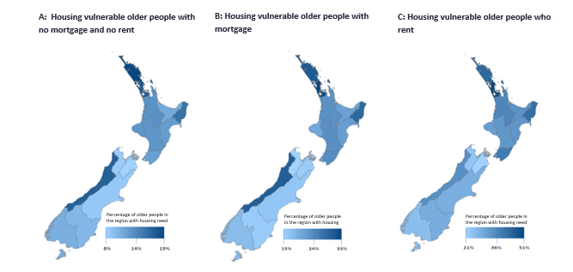

While studies show that higher levels of mortgage debt negatively impact older people’s financial wellbeing, older people who rent are more vulnerable (Hermann, Herbert, & Molinsky, 2020). Research shows that ‘in New Zealand, renting (particularly publicly renting) rather than owning a home in older age was found to be related to economic disadvantage, several unhealthy behaviours and poorer self-reported physical and mental health status’. Moreover, Māori, Pacific peoples, and older women who have higher rates of renting ‘are particularly vulnerable to the negative impact of renting on health’ (Pledger et al., 2019).
The 2022 Review of Retirement Income Policies noted that a decline in homeownership rates could have a significant impact on current and future older people. An increase in the number of older people renting will significantly impact their financial wellbeing since superannuation rates are based on the assumption of home ownership. Moreover, the increase in the number of people over 65 will mean an increase in the number of people renting (Retirement Commission, 2022).

Older Pacific peoples experience the highest proportion of housing vulnerability, particularly for those with housing costs
Housing vulnerability experiences are more acute for some ethnicities. For instance, 60 percent (7,100) of older Pacific peoples experience housing vulnerability. Our analysis of housing tenure and housing experiences shows that older Pacific peoples experience the highest proportion of housing vulnerability irrespective of housing tenure types:
- 72 percent (3,400) of older Pacific peoples who rent experience housing vulnerability;
- 62 percent (2,300) of older Pacific peoples who have a mortgage experience housing vulnerability;
- 41 percent (1,400) of older Pacific peoples with no mortgage or no rent experience housing vulnerability.
Pacific peoples make up 24 percent of those identified as living in severe housing deprivation (Amore et al., 2021). Additionally, Pacific peoples have the lowest home ownership rates compared to any other ethnicity and are disproportionately impacted by homelessness, overcrowding, and unhealthy and damp houses (Ministry for Pacific Peoples, 2022).
Rates of housing vulnerability vary by ethnicity (Figure 13). Thirty-eight percent (11,700) of Asian and Māori (12,100) older people experience housing vulnerability followed by 34 percent (700) of MELAA older people. European older people have the lowest proportion of housing vulnerability at 15 percent (71,000 individuals), although numerically, they make up the largest group of older people who experience housing vulnerability.

Figure 13: Older people with housing vulnerability who have housing costs (mortgage or rent)
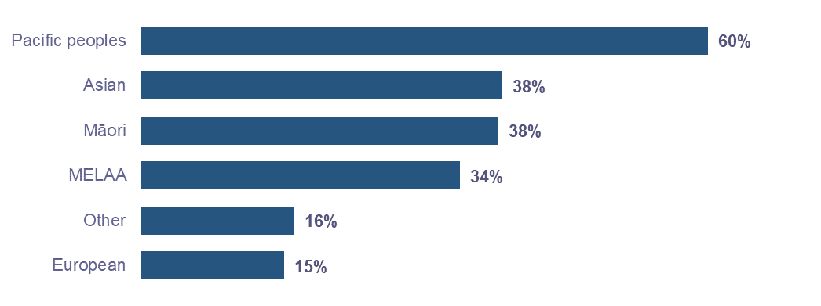

There are some significant differences in housing vulnerability experiences due to ‘overcrowding’ by ethnicity
Older Pacific peoples experience the highest proportion of ‘overcrowding’ at 40 percent (2,800 people), followed by Asian older people at 24 percent (2,800 people) and Māori at 21 percent (2,600 people) (Figure 14). We know that older people in Pacific and Māori communities may live in intergenerational households. While this contributes to overcrowding according to our definitions, for many multigenerational living is a cultural norm and contributes to wellbeing (Social Policy Evaluation and Research Unit, 2015). Therefore, these percentages may not be representative of actual need. The 2018 Census used the Canadian Occupancy National Model which presumes that there should be no more than two people to a bedroom, but that couples and children of certain ages can share a bedroom (Stats NZ, 2020). There is a need for adequate, culturally appropriate, and affordable housing (and measures of housing need) for older people.
Some people who experience overcrowding also experience poor quality housing. Seven in ten older Pacific peoples and nearly 6 in 10 Māori older people who experience overcrowding also experience poor quality housing.

Figure 14: Older people experiencing ‘overcrowding’ by ethnicity
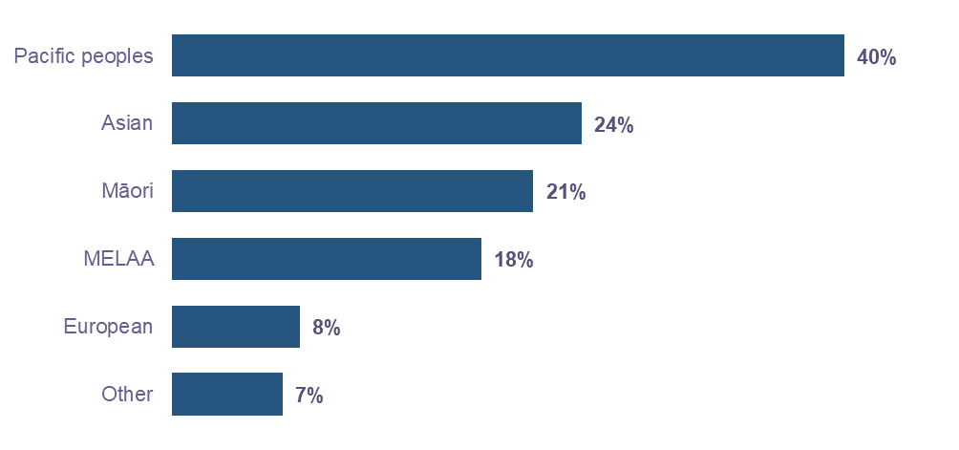

Finance
We defined financial vulnerability as having a receipt of one or more of the following Ministry of Social Development income supports: ​
- Main Benefit (MB)​
- Accommodation Supplement (AS) ​
- Temporary Additional Support (TAS) ​
- Special Needs Grant/s (SNG/SNGs) ​
​
These supports have eligibility criteria (such as income and cash asset limits) that indicate that a recipient is likely experiencing financial hardship. Older people who receive two or more of AS/TAS/SNGs are more likely to be in acute hardship as the requirement for multiple forms of income and asset tested supplementary assistance denotes additional financial needs that are unable to be met through existing income or savings. There are some limitations in using the uptake of financial assistance as a proxy for financial vulnerability as it does not capture those who experience hardship who may not be accessing supports.
In our analysis, we also considered factors like household composition (couple or single or other household) and receipt of superannuation. The household composition variable was made by grouping different categories of usual household residents from the 2018 Census:
  - Those living alone, without other people in their household, are classified as ‘single person household’,
  - Those living with their partner and no others are classified as ‘couple household’ and
  - All other combinations are classified as ‘other household composition’.

8 percent (55,100) of older people experience financial vulnerability
Sixty percent of older people who experience financial vulnerability are receiving either Accommodation Supplement or Temporary Additional Support but no SNG (Figure 15).
Those aged 65-74 experience the highest proportion of vulnerability at 9 percent. However, financial vulnerability decreases as people age. Seven percent of those aged 75-84 experience financial vulnerability followed by 4 percent of those aged 84-95 and 2 percent of those aged 95+.
Further, older women experience similar, but slightly higher, proportions of financial vulnerability than older men. For example, 10 percent of women aged 65-74 experience financial vulnerability compared to 9 percent of men in the same age category. However, other factors may impact women’s financial wellbeing in older age including gender pay gaps, ethnic pay gaps, working part-time, divorce, and the impacts of family violence (Morrissey, 2022).

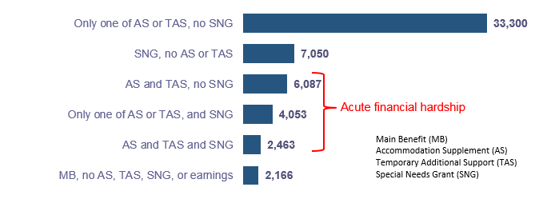
Figure 15: Financial vulnerability experiences of older people by types of financial vulnerability

Older people receiving superannuation also experience financial vulnerability
Among those older people who experience financial vulnerability, a majority applied for either Accommodation Supplement or Temporary Additional Support. Despite receiving superannuation, 47,600 older people experience financial hardship (Figure 16). As noted earlier, superannuation is built around the notion of home ownership. However, an increasing number of older people are ‘struggling to get by’ in retirement, even where a home is owned outright (Retirement Commission, 2022).

Figure 16: Proportion of older people with financial vulnerability with superannuation receipt (NZS) and income band
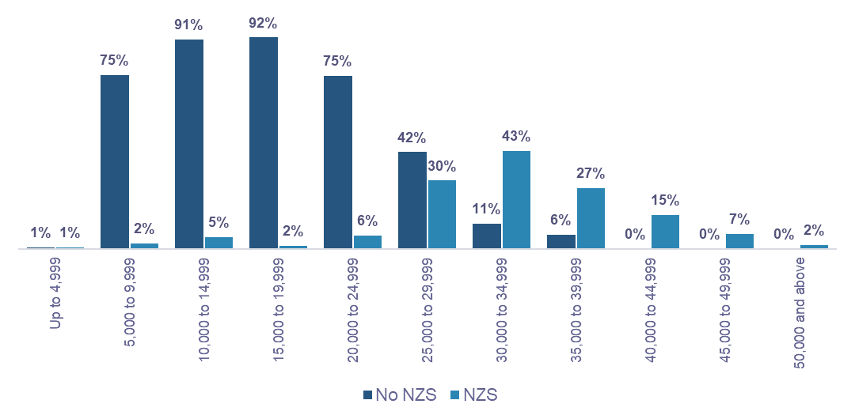

A small number of older people who experience financial vulnerability are not receiving superannuation
We identified a group of older people (6,600 older people) that have a low income (below $35,000), who were not receiving superannuation and were in financial hardship (Figure 16). This may suggest possible application and/or awareness barriers in accessing superannuation such as a challenging application process for superannuation. Some in this group may also be older migrants who do not qualify for NZ Super due to residency status.
Some people receiving NZ Super and on a low income may be older people who have spent time in or moved to a hospital or residential care and their NZ Super rates were reduced to reflect the co-payment aspect across these supports.

Asian and MELAA older people experience the highest proportion of financial vulnerability
Proportions of financial vulnerability vary across ethnicities (Figure 17). Twenty-eight percent (11,700) of Asian older people and (1,200) of MELAA older people have financial vulnerability. 25 percent (5,000) of older Pacific peoples experience financial vulnerability. 18 percent (8,500) of Māori older people experience financial vulnerability. European older people experience the lowest proportion of financial vulnerability at 5 percent (32,200 people).

Figure 17: Proportion of older people with financial vulnerability by ethnicity
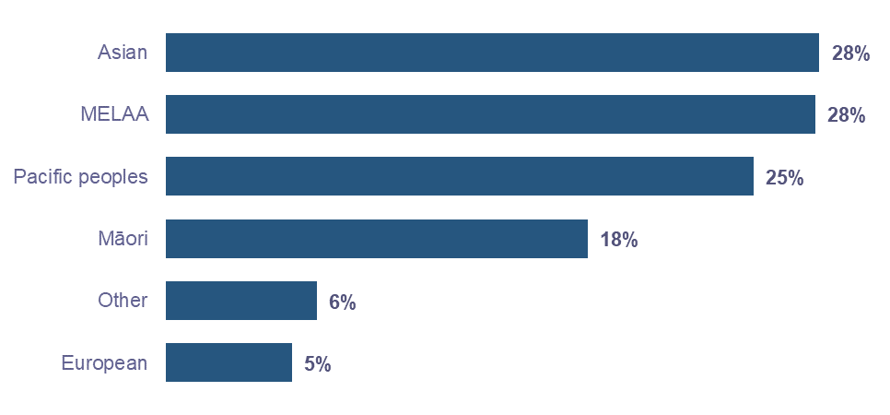

Older people living in single or couple households have lower proportions of financial vulnerability ​
Most older people live in couple or single households (81 percent). About 19 percent (112,200 people) live in “other households”, for example, living with extended family. These older people experience the highest proportion of financial vulnerability (Figure 18). Sixteen percent (18,300) of older people living in “other households” experience financial hardship compared to 11 percent (17,100) of older people living in single households or 3 percent (9,000) of older people living in coupled households.

Figure 18: Older people with financial vulnerability by household composition
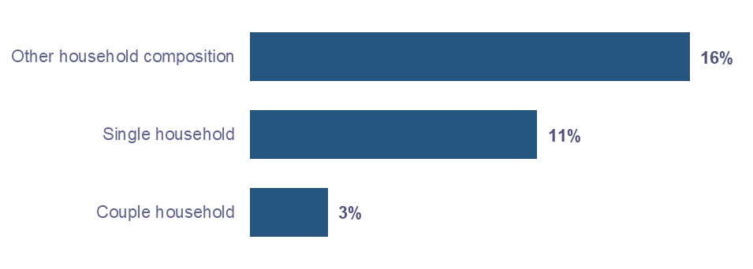

Social connection
Social networks are important for psychological well-being in later life. Research shows that in older age, loneliness is linked to both demographic and health related variables (Kim & Lee, 2022). ‘Psychological factors such as low self-efficacy beliefs, negative life events, and a low level of personal resources’ are also associated with loneliness (Boehlen et al., 2021). In later life, loneliness has been linked to decreased health-related quality of life as well as with a greater mortality risk (Boehlen et al., 2021).
The social connection vulnerability indicator uses 2018 Census variables to identify whether someone lives alone and does not volunteer nor help family or whānau as a proxy for social isolation. This is not the same as loneliness. In the 2018 General Social Survey, 8 to 14.2 percent of people aged 65 and over reported feeling lonely some, most or all of the time in the last 4 weeks, compared to 14.7 to 18.5 percent of the general population (Stats NZ, 2018).
Our social connection domain analysis was based on self-reported Census 2018 data, for which the response rate was 76 percent of people aged 65 and over in New Zealand (523,900 out of 686,600 older people).

17 percent (89,000) of older people experience social connection vulnerability
Our analysis shows that this vulnerability increases significantly as people age (Figure 19). We also found women experience significantly higher proportions of vulnerability in this domain compared to men. This trend may be driven by life expectancy differences to some extent and other factors such as education and financial status (Kim & Lee, 2022).

Figure 19: Proportion of older people with social connection vulnerability by age and sex
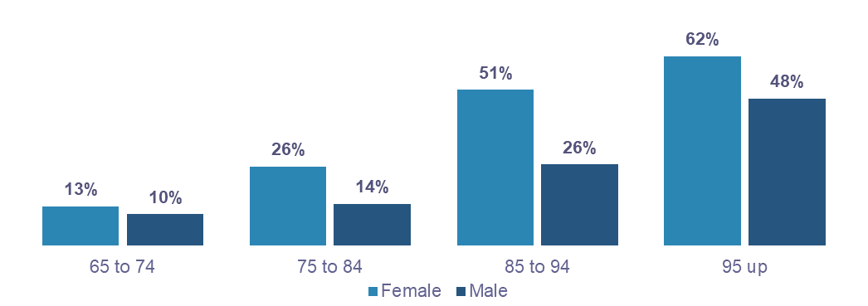

European older people experience the highest rates of social connection vulnerability, proportionally and numerically
18 percent (83,200) of European older people experience vulnerability in this domain, followed by 15 percent (4800) of Māori older people and 14 percent (270) MELAA older people. Older Asian people and Pacific peoples both had the same proportions of social connection vulnerability at 8 percent or 2,300 and 1,000 people, respectively (Figure 20). One explanation for the lower rates of vulnerability among older Pacific peoples is multigenerational living. Multigenerational living has several wellbeing benefits. It helps in ‘building and maintaining vā and relationships between generations, caring for the elderly and children, transferring of cultural knowledge, and building household wealth and capital.’ (Rohorua et al., 2022).

Figure 20: Proportion of social connections vulnerability by ethnicity
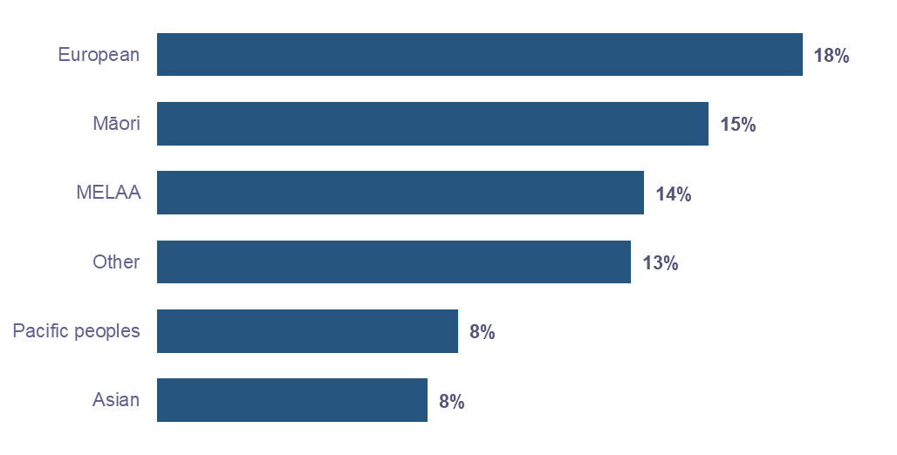

Access
Access significantly impacts service use, especially for older people. To understand access vulnerability, we used the indicators:
- having a driver’s licence and
- living in a household with a motor vehicle
We defined access vulnerability ‘not having a driver’s licence and not owning a vehicle in the household.’ Our access domain analysis was based on self-reported Census 2018 data, for which the response rate was 81 percent of people aged 65 and over in New Zealand (556,300 out of 686,600 older people).
Our measures are a proxy to an older person’s access to transport around a community. They only consider one definition of access (i.e., ability to move around one’s community) and have not yet included wider measures such access to other modes of transport such as public transport and ride-share services. Additionally, some older people may face challenges in using a vehicle due to health issues, such as impaired eyesight or limited mobility.

3 percent (17,700) of older people experience access vulnerability
The percentage of people experiencing access vulnerability increases with age. The proportion of access vulnerability significantly increases with age. Two percent of those aged 65-74 experience access vulnerability compared to 4 percent for those aged 75-85. Seven percent of those aged 85-94 and 13 percent of those aged 95 + experience access vulnerability (Figure 21).

Figure 21: Older people with access vulnerability by age
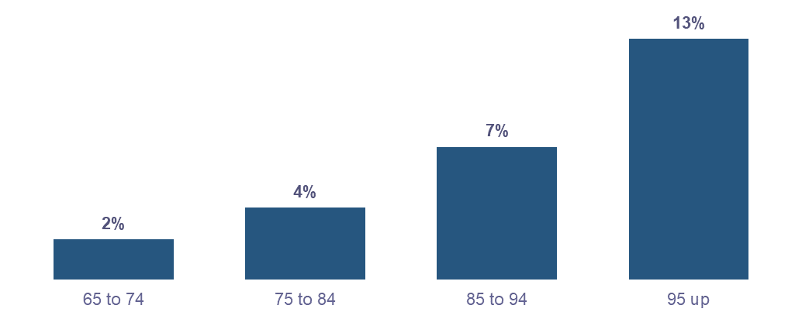

By ethnicity, Asian older people have the highest access vulnerability at 10 percent (3,400 individuals), followed by older Pacific peoples (1,200 individuals) and MELAA older people (200 individuals) at 9 percent, Māori older people at 5 percent (1,700 older people) and European older people at 2 percent (12,000 individuals) (Figure 22).

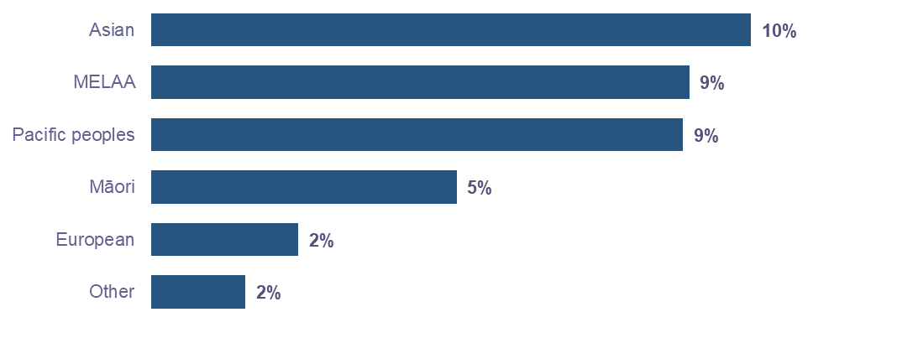
Figure 22: Older people with access vulnerability by ethnicity

Significantly more women compared to men experience access vulnerability
Of those experiencing accessibility vulnerability, 79 percent (14,000) are women and 21 percent (3,600) are men. Moreover, women experience significantly higher rates of vulnerability in this domain. We found that 5 percent of women compared to 1 percent of men experience access vulnerability. This trend is also evident across ethnicities. MEELA and Asian women experience the highest proportion of access vulnerability at 12 percent compared to older people in all other ethnic and sex subgroups (Figure 23).

Figure 23: Older people with access vulnerability by ethnicity and sex
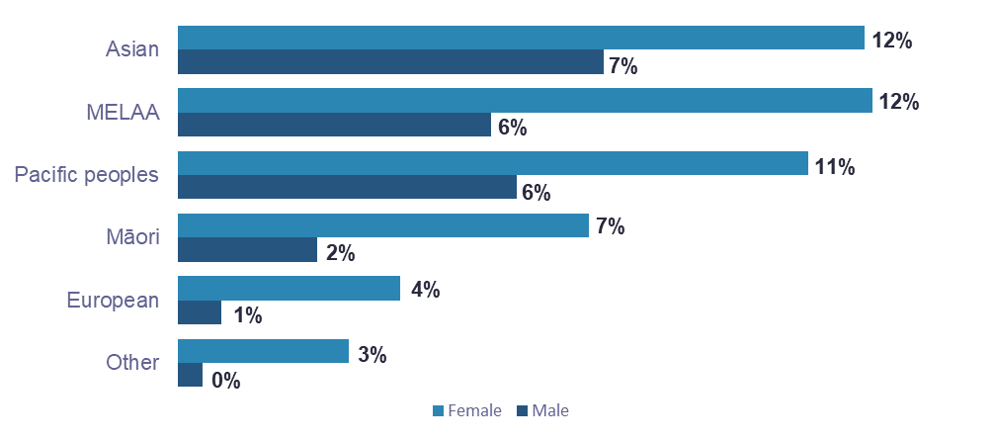

Multiple disadvantage

Older people who experience disadvantage in multiple domains have complex needs (Smith, Peach, & Cording, 2019). For people experiencing multiple needs, one need often creates another or exacerbates others (McCarthy, Parr, Green, & Reeve, 2020). For instance, health status is linked to social determinants of health. These determinants – including housing environment, literacy, food security, social support and access to health and social care – account for between 30-55% of health outcomes (World Health Organisation, 2021). Therefore, assessing multiple domains in conjunction allows a more comprehensive understanding of people’s needs.

13 percent (90,400) of older people experience multiple disadvantage
In this group, 80 percent (71,900) of older people experience vulnerability in two domains. A further 17 percent (15,600 people) experience vulnerability in three domains, 3 percent (2,600 people) experience vulnerability in four domains and 0.3 percent experience vulnerability in all five domains (Figure 24). Overall, a slightly higher proportion of women (14 percent) experience multiple disadvantage compared to men (12 percent).

Figure 24: Older people by number of domains with vulnerability
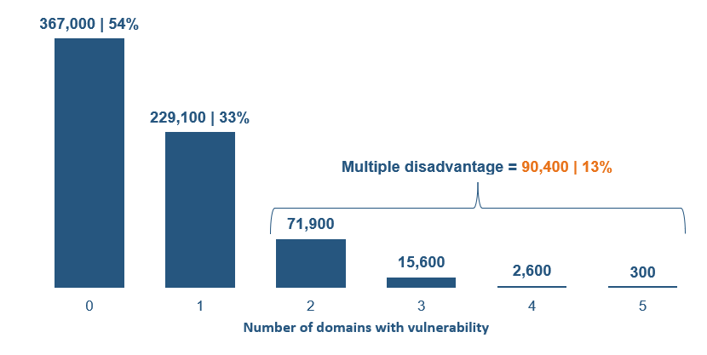

Older people aged 85-94 are most likely to experience multiple disadvantage
The proportion of older people with any vulnerability increases with age. However, the proportion of older people who experience multiple disadvantage (need in 2 or more domains) is highest for those aged 85 to 94 years. Eighteen percent of 85 to 94 year-olds experienced multiple disadvantage, compared to 12 percent of 65 to 74 year-olds, 14 percent of 75 to 84 year-olds and 16 percent of people aged 95 and older (Figure 25).

Figure 25: Multiple disadvantage experiences by age
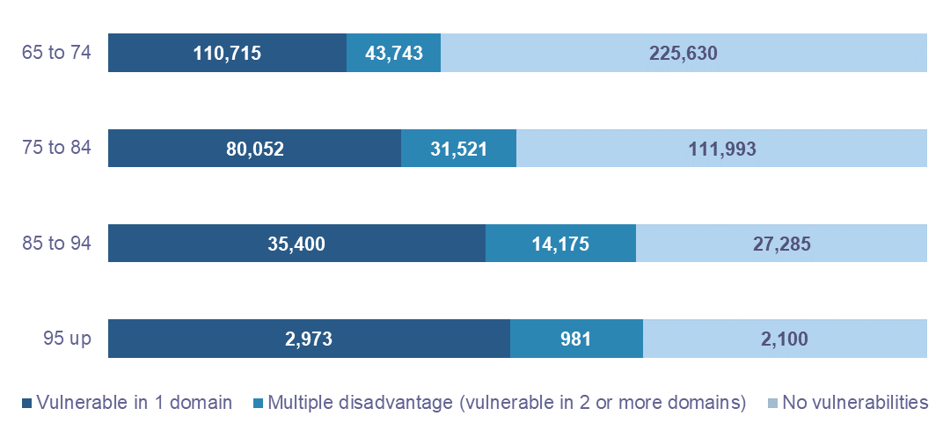

Older Pacific peoples experience the highest proportion of multiple disadvantage
Irrespective of sex, older Pacific peoples were most likely to experience multiple disadvantage at 27 percent (5,400 people) compared to other ethnicities, followed by 24 percent of older Māori women (6,100 people) and 23 percent of older Asian women (5,200 people) (Figure 26).

Figure 26: Older people with multiple disadvantage by sex and ethnicity
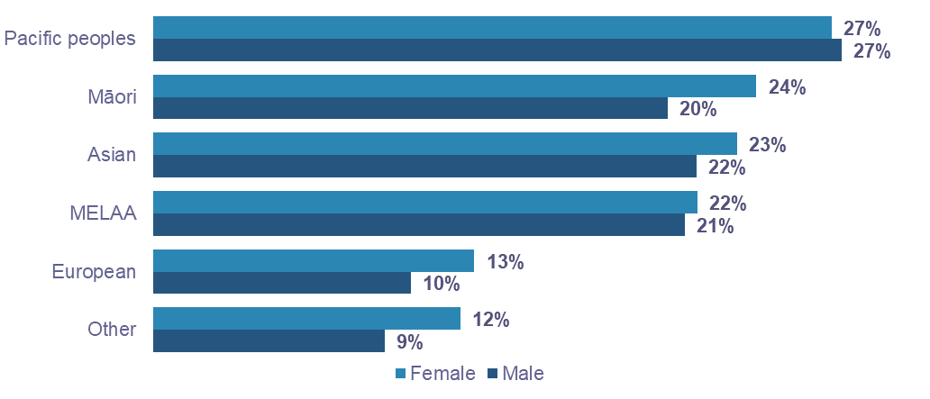

Auckland, Gisborne, and the West Coast have the highest proportion of older people who experience multiple disadvantage
Sixteen percent of older people living in Auckland experience multiple disadvantage (29,100 people), followed by 15 percent of older people living in Gisborne (1,100 people) and the West Coast (900 people) (Figure 27).

Figure 27: Older people with multiple disadvantage by region

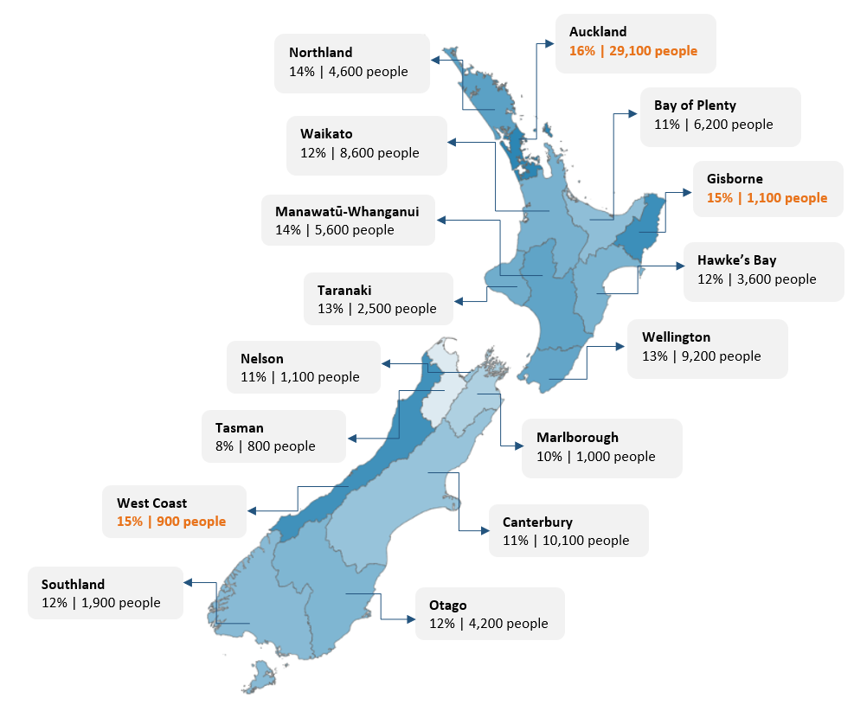

Older people who experience multiple disadvantage have a spectrum of need
Older people may experience multiple disadvantage due to a range of vulnerability combinations. However, some combinations of vulnerabilities were more likely to result in an experience of multiple disadvantage compared to other combinations. We identified the most likely two, three, and four domain vulnerability combinations that lead to multiple disadvantage (Figure 28).

Figure 28: Types of vulnerability and multiple disadvantage experienced by older people
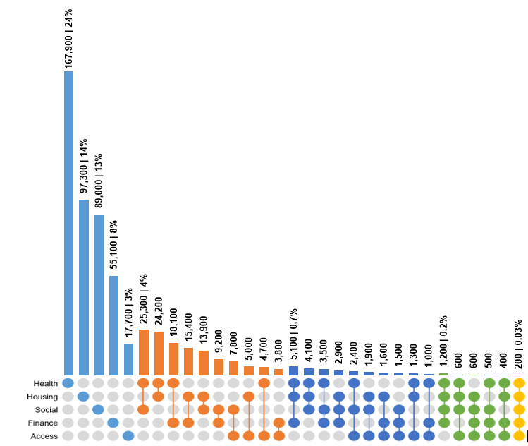
To read this graph:
Each column in the graph corresponds to the column of dots directly below it. The shaded dots indicate which of the domains on the left are selected. For example, the first column in the graph corresponds to those with a health vulnerability which totals to 167,900 people.
The numbers in this graph are not mutually exclusive. For example, a person experiencing health and housing vulnerability is included in the health, housing, and housing and health columns.
The denominator used to calculate percentages in this graph is the total study population: 686,600 older people.

Multiple disadvantage in two domains is mostly due to poor health and lack of social connection
25,300 older people experience multiple disadvantage due to vulnerability in health and social connection; this is the most common combination for multiple disadvantage (Figure 28). Older people who have multiple mental health conditions also have higher rates of vulnerability in the social connections domain, compared to those with other physical or mental health condition combinations.

43 percent (15,400) of older people who experience financial vulnerability also experience housing vulnerability
These older people mainly received either AS or TAS (10,500 older people or 68 percent of those with finance and housing vulnerability). Further, this group experienced higher rates of overcrowding compared to those who only experience housing vulnerability. Twenty-one percent of older people with financial and housing vulnerability experience overcrowding compared to 11 percent of those who experience housing but not financial vulnerability.

Some older people who experience multiple disadvantage are in acute hardship
Of those experiencing multiple disadvantage in three domains, 5,100 older people (0.7 percent of the total older people population) experience vulnerability in housing, health, and finance (Figure 28). Among these older people we identified those in acute hardship:
  - 25 percent (1,300) of those experiencing multiple disadvantage in health, housing, and finance were experiencing acute financial hardship. That is, they were receiving at least two benefits out of Accommodation Supplement, Temporary Additional Support and Special Need Grant/s.
  - 16 percent of those experiencing multiple disadvantage in health, housing, and finance have multiple mental health conditions, compared with only 2.5 percent of the older population who experience health vulnerability but are not vulnerable in the housing or financial domains.

Mental health has a significant impact on older people’s experience of multiple disadvantage
The overlap of data across the health, housing, finance, and social connection domains shows that older people with mental health conditions experience higher proportions of vulnerability in housing and finance compared to those with a combination of physical and mental health conditions or those with physical conditions only. About 19 percent of older people in this group experience financial vulnerability compared to 9-13 percent of those with other health condition combinations (Figure 29).
Further, this group of older people experience the highest proportion of housing vulnerability at 26 percent, compared to those with a combination of physical and mental health conditions (23 percent) or physical health conditions only (20 percent). Similarly, a higher proportion of this group experience vulnerability in social connection (26-30 percent), compared to those with a combination of physical and mental health conditions (25 percent) or physical health conditions only (21 percent) (Figure 29).

Figure 29: Older people with housing, finance or social vulnerability by health vulnerability type
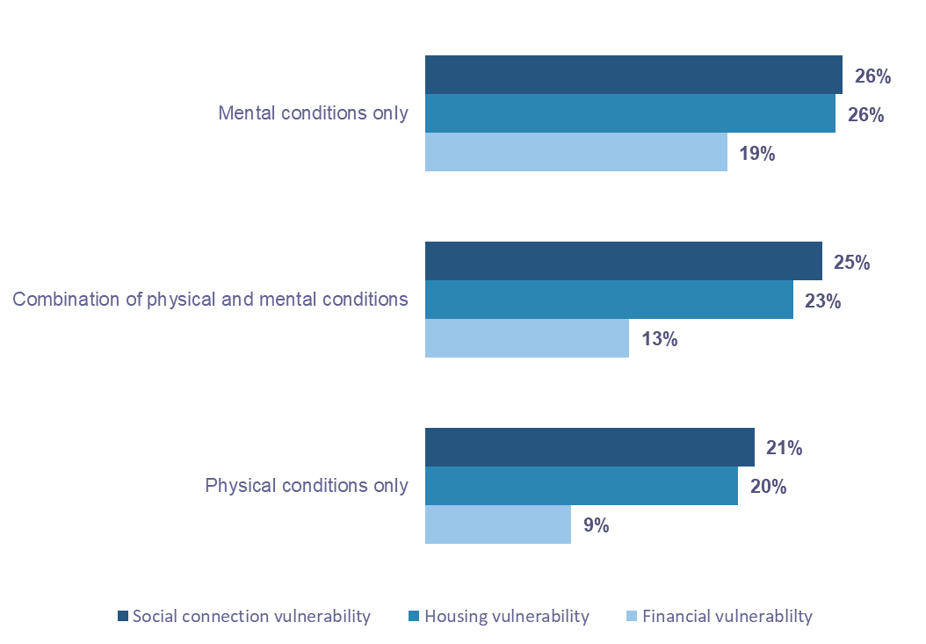

Conclusion
While most older people are doing well, the older people we identified experience vulnerability and multiple disadvantage and, in some instances, are in acute hardship. For example, there are people on multiple income tested benefits with multiple mental health conditions. Additionally, we found considerable differences in experiences of vulnerability and multiple disadvantage based on age, sex, and ethnicity.
Our findings of varied experiences of vulnerability for older people are consistent with the inequitable experiences and outcomes of Māori and Pacific peoples across the life course. Older Pacific peoples not only experience the highest proportion of multiple disadvantage across ethnicities, but they also experience the highest proportion of housing vulnerability across ethnicities, irrespective of housing tenure type.
The insights presented in this report raise some important policy considerations, especially around how services can be future proofed and improved across the areas of health care, housing, and income support to better meet the complex needs of older people.
It is important for policy makers to evaluate how the current service support landscape supports those experiencing hardship and identify opportunities where agencies can fill gaps or eliminate barriers.

Review of Retirement Income Policies 2022
The 2022 Review of Retirement Income Policies was released towards the end of this phase of analysis. Even though our datasets are from 2018, our insights – especially in the housing and finance domains – align with the review’s findings of people ‘struggling to get by’ in retirement (Retirement Commission, 2022).

Notes
The quantitative data in this project is supplemented by advice from an Expert Advisory Group (EAG) and a wider engagement strategy with community stakeholders. The EAG group was set up to provide external, independent advice on the project to ensure evidence development is contextualised and interpreted to reflect community perspectives and lived experiences.
Codes used to generate the analyses in this paper are found here - https://github.com/nz-social-wellbeing-agency/definitions_library
Numbers relating to cohort counts in the text have been rounded to the nearest hundred.

References
Anae, A., Mila-Schaaf, K. Teu le Va (2010). Relationships across research and policy in Pasifika Education: A collective approach to knowledge generation and policy development for action towards Pasifika education success. Ministry of Education, New Zealand. https://thehub.swa.govt.nz/assets/documents/42367_TeuLeVa-30062010_0.pdf
Amore, K., Viggers, H., Howden-Chapman, P. (2021). Severe housing deprivation in Aotearoa New Zealand, 2018: June 2021 update. Wellington: Ministry of Housing and Urban Development.
Associate Minister of Health. (2016). Healthy Ageing Strategy. Wellington: Ministry of Health
Boehlen, F.H., Maatouk, I., Friederich, H.C., Schoettker, B., Brenner, H., & Wild, B. (2021). Loneliness as a gender-specific predictor of physical and mental health-related quality of life in older adults. Quality of Life Research, 31, 2023-2033.
Edwards, W., Theodore, R., Ratima, M., & Reddy, R. (2018). Māori positive ageing. The New Zealand Medical Journal, 131(1484), 10-12.
Edwards, W. (2010) ‘Taupaenui: Māori Positive Ageing’. PhD Thesis. Massey University.
Ellison-Loschmann, L., & Pearce, N. (2006). Improving access to health care among New Zealand's Maori population. American journal of public health, 96(4), 612–617.
Graham, R., & Masters-Awatere, B. (2020). Experiences of Māori of Aotearoa New Zealand's public health system: A systematic review of two decades of published qualitative research. Australian and New Zealand Journal of Public Health, 44(3), 193-200.
Hermann, A., Herbert, C., & Molinsky, J. (2020). The Association Between High Mortgage Debt and Financial Well-Being in Old Age. Joint Center for Housing Studies Harvard University.
Hokowhitu, B., Oetzel, J.G., Simpson, M. et al. (2020). Kaumātua Mana Motuhake Pōi: a study protocol for enhancing wellbeing, social connectedness and cultural identity for Māori elders. BMC Geriatric, 20, 377, 2.
Hyslop, D., Riggs, L., & Maré, D. (2022). The impact of the 2018 Families Package Winter Energy Payment policy. Motu Working Paper 22-09. Wellington: MOTU.
Howden-Chapman, P., Fyfe, C., Nathan, K., Keall, M., Riggs, L., Pierse, N. (2021). The Effects of Housing on Health and Well-Being in Aotearoa New Zealand. New Zealand Population Review, 47, 16-32.
Jaye, C., McHugh, J., Doolan-Noble, F., Wood, L. (2022). Wellbeing and health in a small New Zealand rural community: Assets, capabilities and being rural-fit. Journal of Rural Studies, 92, 284-293.
Kim, Y.B., & Lee, S.H. (2022). Gender differences in correlates of loneliness among community-dwelling older Koreans. International Journal of Environmental Research and Public Health, 19(12), 7334-7345.
McLeod Keith. (December 2018). Our people – Multidimensional wellbeing in New Zealand. Analytical Paper 18/04. New Zealand Treasury. https://www.treasury.govt.nz/sites/default/files/2018-11/ap18-04.pdf
Ministry of Health (2018). Health and Independence Report 2017. The Director-General of Health’s Annual Report on the State of Public Health. Wellington: Ministry of Health. https://www.health.govt.nz/system/files/documents/publications/health-and-independence-report-2017-v2.pdf
Ministry for Pacific Peoples (2022). Fale mo Aiga: Pacific housing strategy and action plan 2030. Wellington: Ministry for Pacific Peoples. https://www.mpp.govt.nz/assets/Resources/Housing/Fale-mo-Aiga-Booklet-7_0.pdf
Morrissey, S. (2022). What does retirement look like for women? Wellington: Retirement Commission. https://assets.retirement.govt.nz/public/Uploads/Retirement-Income-Policy-Review/2022-RRIP/TAAO-_What-does-retirement-look-like-for-women_2022.pdf
Northland District Health Board, (2008). Health of older people Strategic Action Plan, 2008-2013. Northland: New Zealand. https://www.northlanddhb.org.nz/assets/Communications/Publications/hop-strategy-final-2008.09.15.pdf
Office for Seniors (2021). Better later life action plan. Wellington: Office for Seniors. https://officeforseniors.govt.nz/better-later-life-strategy/action-plan/
Pledger, M., McDonald, J., Dunn, P., Cumming, J., & Saville-Smith, K. (2019). The health of older New Zealanders in relation to housing tenure: Analysis of pooled data from three consecutive, annual New Zealand Health Surveys. Australian and New Zealand Journal of Public Health, 43(2), 182-189.
Retirement Commission (2022). Review of retirement income policies. Wellington: Retirement Commission. https://assets.retirement.govt.nz/public/Uploads/Retirement-Income-Policy-Review/2022-RRIP/RRIP_2022.pdf
Rohorua, H. T., Natua, J.T., Tapu, M.L. & Koloto, M. L ., (2022). Report on Housing and Retirement among Pacific Peoples in Aotearoa. Ministry for Pacific Peoples. Wellington, New Zealand.
Smith, C., Peach, E.P., & Cording, J., (2019). The impact of multiple disadvantage on subjective wellbeing: New Zealand Families. Kōtātā Insight, December 2019.
Social Policy Evaluation and Research Unit, (2015). Families and Whānau status report 2015. Wellington: Social Policy Evaluation and Research Unit. https://thehub.swa.govt.nz/assets/Uploads/Families-and-Whanau-status-report-2015.pdf
Social Investment Agency, (2017). Social Investment Agency’s beginners’ guide to the Integrated Data Infrastructure. Wellington: Social Investment Agency. https://swa.govt.nz/assets/Documents/Beginners-Guide-To-The-IDI-December-2017.pdf
Stats NZ (2018). National ethnic population projections, by age and sex, 2018(base)-2043. Retrieved from National and subnational period life tables: 2017–2019 | Stats NZ
Stats NZ (2018, September 25). Wellbeing statistics 2018. Retrieved from https://www.stats.govt.nz/information-releases/wellbeing-statistics-2018
Stats NZ (2020). Almost 1 in 9 people live in a crowded house. Wellington: Statistics New Zealand. https://www.stats.govt.nz/news/almost-1-in-9-people-live-in-a-crowded-house
Stats NZ (2021). National and subnational period life tables: 2017-2019. Wellington: Statistics New Zealand. https://www.stats.govt.nz/information-releases/national-and-subnational-period-life-tables-2017-2019/
Stats NZ (2022). One million people aged 65+ by 2028. Wellington: Statistics New Zealand. https://www.stats.govt.nz/news/one-million-people-aged-65-by-2028/
Waitangi Tribunal (2023). Hauora: Report on stage one of the health services and outcomes Kaupapa Inquiry. Wellington, New Zealand.
Webber, A., Anastasiadis, S., & Badenhorst, S. (2022). Wellbeing during the first year of COVID-19. Wellington: Social Wellbeing Agency.
World Health Organisation. (2021, June 14). Promoting healthy ageing in Singapore. Promoting healthy ageing in Singapore (who.int)

Further reading
Mental Health and Wellbeing Commission. (2022 November). COVID-19 and the wellbeing of older people in Aotearoa. Eng_OlderPeopleWellbeing_SummaryPaper_pdf.pdf (mhwc.govt.nz)
Statistics New Zealand. (2023, January 18). Aotearoa’s housing often unsuited to Pacific families. Aotearoa’s housing often unsuited to Pacific families | Stats NZ
Statistics New Zealand. (2020). Housing in Aotearoa: 2020. Housing in Aotearoa: 2020 (stats.govt.nz)

The IDI is a large research database that collects individual level data about people and households. It includes administrative data about education, income, benefits, migration, justice, and health and comes from government agencies, Stats NZ surveys, and non-government organisations (NGOs).
One million people aged 65+ by 2028 | Stats NZ
For more information, see Social Investment Agency (2017) https://swa.govt.nz/assets/Documents/Beginners-Guide-To-The-IDI-December-2017.pdf
These categories are based on Stats NZ definitions.
Denominator based on health datasets = 686,600 older people
Canadian Crowding Index - Stats NZ DataInfo+
Those without shelter + those in temporary accommodation + those sharing accommodation. See Table B, p 34.
See Table 7, p 20
Denominator: total based on individual tenure status
Auckland and Gisborne have the highest proportions of renting households for older people. 18 percent of older people in Auckland and Gisborne rent, compared to 14 percent of older people across NZ.
https://retirement.govt.nz/news/latest-news/2022-review-of-retirement-income-policies-released-highlights-the-importance-of-nz-super/
Total older Pacific peoples population is 19,890 or 3 percent of the total older people population.
Severe housing deprivation is synonymous with homelessness. It refers to people living in severely inadequate housing due to a lack of access to minimally adequate housing (Amore et al, 2013). This means not being able to access a private dwelling to rent or own that has all basic amenities. Housing that lacks at least two of the three core dimensions of housing adequacy – habitability, security of tenure, and privacy and control – is deemed severely inadequate.
For Pacific peoples aged 70 years and over, 27.4 percent lived in a crowded home, compared with just 2.7 percent of this age group in the total population; https://www.stats.govt.nz/assets/Uploads/Reports/Housing-in-Aotearoa-2020/Download-data/housing-in-aotearoa-2020.pdf, p 98; Māori who lived in crowded households (1 or more bedrooms needed) were also more likely to be culturally connected and engaged than Māori who lived in households that had one or more spare bedrooms. See: https://www.stats.govt.nz/reports/te-pa-harakeke-maori-housing-and-wellbeing-2021
Includes benefits such as Emergency Benefit, Supported Living Payment, Jobseeker Support, Widow’s Benefit, and Sole Parent Support. Excludes those who have earnings and are receiving a main benefit.
The number of those experiencing vulnerability could be higher since our definition of financial vulnerability was limited to receipt of income tested benefits. Further refinement is possible but not in the scope of the paper.
‘Differential mortality could provide another explanation for the high wellbeing of older people. If people with low wellbeing are more likely to die at an earlier age, this could cause a ‘survivor effect’. The relatively high wellbeing of older people could be a result of the prior death of people with especially low wellbeing, and the associated changes in the composition of the group of older people still alive.’ (New Zealand Treasury, 2018)
The perception and evaluation of a person concerning his/her biopsychosocial well-being
Denominator based on 2018 Census = 523,900 older people
The va/va'a/vaha is a pan-Pacific notion that describes the spatial and relational context within which secular and spiritual relationships unfold. Social, spiritual, and relational contexts allow for personal and collective well-being and growth through knowledge generation, social action, and cultural transformation (Anae, 2007).
Denominator based on 2018 Census = 556,300 older people
10 percent of total older people population
The numbers in this graph are mutually exclusive. For example, a person experiencing health and housing vulnerability is only included in multiple disadvantage (3rd bar in Figure 24).
Housing is part of our key physical and social infrastructure, and an important determinant of health. Housing quality can affect mental health, although the evidence is mixed. (Howden-Chapman et al., 2021).

